
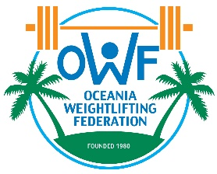
TRANSPORT FORM

2025 OCEANIA JUNIOR AND YOUTH WEIGHTLIFTING CHAMPIONSHIPS
MELBOURNE APRIL 11-13

The Weightlifting Federation wishes to inform the Organising Committee of their transport requirements :

COUNTRY | Number  of persons | Arrival Date | Flight Number | Arrival Time | Departure Date | Flight Number | Departure Time

Name: ______ Signature:___ _____________ Date: ___________

Please email this transport form not later then March 8th 2025 to:

Paul Coffa
OWF General Secretary
E-mail: owf@bigpond.com
Mobile: +61 457778900

